November 10, 2014

ATI Allegheny Ludlum
Midland, PA

RE: Caster Slab Optimization Changes

Dear Mr. Robert Mintus,

AS&E, an ATI approved vendor, is pleased to present this Time and Materials quote for changes to the Slab Cutting Optimization for the Midland PA Meltshop facility.

The scope of work under this proposal is described in the accompanying document, and the first task in this work will be to finalize any remaining questions raised in this document. The work includes:

- Finalizing document details
- Coding, testing, and simulating the optimization results
- Updating the documentation
- Installation and monitoring

The work would be performed by Richard Burgess and Dan Houck, with Mr. Burgess serving as Project Manager and Task Coordinator for AS&E. The work estimate is 90 hours at the hourly rate of $90, and any expense to AS&E for required materials (no materials requirements are anticipated for this project) will be billed at cost plus 10%.

Once a Purchase Order is received, AS&E would be available to begin the task work November 10, 2015, with the conclusion of work being anticipated for 10 December, 2015.

We appreciate your consideration for this work. Please feel free to contact me with any questions or issues.

Sincerely,

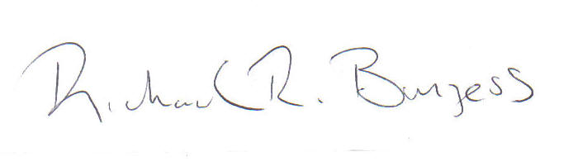

Richard R. Burgess

